**DAILY ONLINE ACTIVITIES SUMMARY**

|  |  |  |  |  |  |  |  |
| --- | --- | --- | --- | --- | --- | --- | --- |
| **Date:** | **31-05-2020** | | | | **Name:** | **K Manasa** | |
| **Sem & Sec** | **8th 'A'** | | | | **USN:** | **4AL6CS043** | |
| **Online Test Summary** | | | | | | | |
| **Subject** | | **No test conducted** | | | | | |
| **Max. Marks** | | **-** | | **Score** | | **-** | |
| **Certification Course Summary** | | | | | | | |
| **Course** | **Python for Machine learning** | | | | | | |
| **Certificate Provider** | | | **Great learning** | **Duration** | | | **3hr** |
| **Coding Challenges** | | | | | | | |
| **Problem Statement:C progam to print right angled traigle numbers** | | | | | | | |
| **Status:Solved** | | | | | | | |
| **Uploaded the report in Github** | | | | **Yes** | | | |
| **If yes Repository name** | | | | **Manasa** | | | |
| **Uploaded the report in slack** | | | | **Yes** | | | |

Certification Course Details: (Attach the snapshot and briefly write the report for the same)

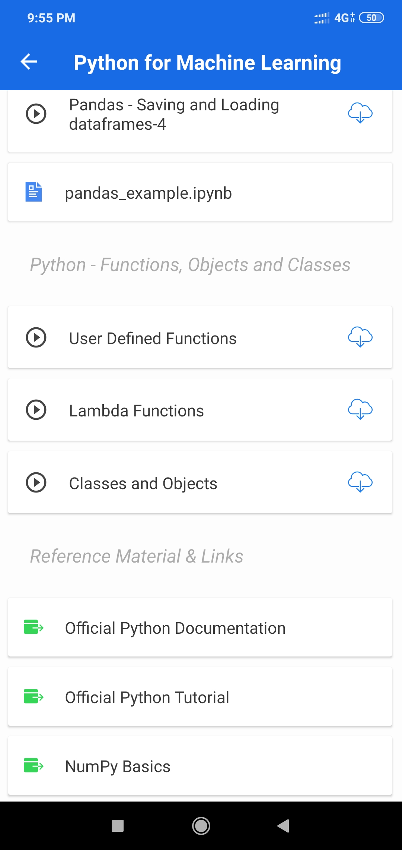

Coding Challenges Details: (Attach the snapshot and briefly write the report for the same)